Project Title: TRAFFIC MANAGEMENT

Project ID: proj_223733_Team_4

College: Gnanamani College of Technology

College code: 6208

Branch: B.Tech-Information Technology

Year: IIIrd year

**TRAFFIC MANAGEMENT**

1.Traffic flow optimization:

• This module uses an Min-cost flow algorithm that optimize traffic flow by adjusting traffic light timings dynamically based on real time traffic data.

2.Adaptive route planning:

• This module uses an Traffic routing algorithm that suggests alternative routes to drivers based on current traffic conditions, accidents and avoiding traffic jams.

3.Public transportation scheduling:

• This module uses an Shortest path first and A* algorithm to optimize the schedules of buses, trains and other public transportation modes based on demand patterns.

4.Smart traffic signage:

• This module uses an Linear regression algorithm that dynamically changes digital traffic signs based on real time traffic conditions, construction zones or emergencies, providing up-to-date information to drivers and improving traffic management.

5.Traffic incident detection:

• This module uses an Histogram of oriented gradients(HOG) and Linear SVM (Support vector machine) algorithm that uses real time traffic data and incident reports to detect accidents or road accidents promptly, allowing for faster emergency response and traffic rerouting.

**Architecture of traffic management:**

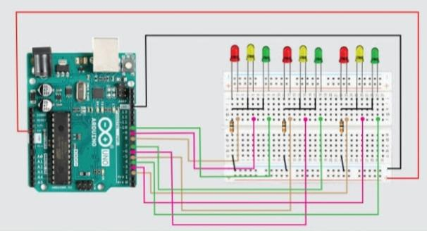

**Send Data to the Traffic Information Platform:**

You need a way to send the collected data to the Traffic Information Platform. You can use various methods such as HTTP requests, MQTT, or other IoT protocols. Here’s an example of how to send data using HTTP:

Import requests

# Replace with your Traffic Information Platform’s API endpoint

Api_url = <https://your-traffic-api.com/data>

# Data to send (modify this according to your data format)

Traffic_data = {

“location”: “Intersection A”,

“vehicle_count”: 100,

“average_speed”: 45,

# Add more data fields as needed

# Send data using a POST request

Response = requests.post(api_url, json=traffic_data)

If response.status_code == 200:

Print(“Data sent successfully”)

Else:

Print(“Failed to send data. Status code:”, response.status_code)

**Handle Data on the Traffic Information Platform:**

Set up the Traffic Information Platform to receive and process incoming data. You will need a web server, database, and data processing logic on this platform to store and analyze the data. Python, along with web frameworks like Flask or Django, can be used for building the server-side logic.

**TRAFFIC MANAGEMENT :**

The platform to receive and display real-time traffic data by using html , css , javascript.

**HTML**:

<!DOCTYPE html>

<html lang=”en”>

<head>

<meta charset=”UTF-8”>

<meta name=”viewport” content=”width=device-width, initial-scale=1.0”>

<title>Traffic Management</title>

<link rel=”stylesheet” href=”styles.css”>

</head>

<body>

<div id=”traffic-light”>

<div id=”red” class=”light”></div>

<div id=”yellow” class=”light”></div>

<div id=”green” class=”light”></div>

</div>

<script src=”script.js”></script>

</body>

</html>

**CSS** :

Body{

Display: flex;

Justify-content: center;

Align-items: center;

Height: 100vh;

Margin: 0;

Background-color: #333;

}

#traffic-light {

Display: flex;

Flex-direction: column;

Align-items: center;

}

.light {

Width: 100px;

Height: 100px;

Border-radius: 50%;

Margin: 5px;

}

#red {

Background-color: #ff0000;

}

#yellow {

Background-color: #ffff00;

}

#green {

Background-color: #00ff00;

}

**JAVASCRIPT** :

Const lights = [‘red’, ‘yellow’, ‘green’];

Let currentIndex = 0;

Function changeLight() {

Document.getElementById(lights[currentIndex]).style.backgroundColor = ‘#333’;

Current

**Android App (Java):**

Here’s a simplified Android app in Java that displays real-time traffic data :

**Program** :-

Import androidx.appcompat.app.AppCompatActivity;

Import androidx.recyclerview.widget.LinearLayoutManager;

Import androidx.recyclerview.widget.RecyclerView;

Import android.os.Bundle;

Import android.widget.Toast;

Import com.google.android.gms.maps.model.LatLng;

Import com.google.maps.android.SphericalUtil;

Import java.util.ArrayList;

Import java.util.List;

Public class MainActivity extends AppCompatActivity {

Private RecyclerView recyclerView;

Private List<Traffic> trafficList;

Private TrafficAdapter trafficAdapter;

@Override

Protected void onCreate(Bundle savedInstanceState) {

Super.onCreate(savedInstanceState);

setContentView(R.layout.activity_main);

recycler View = findViewById(R.id.recyclerView);

recyclerView.setLayoutManager(new LinearLayoutManager(this));

trafficList = new ArrayList<>();

// Adding dummy data for traffic

trafficList.add(new Traffic(“A”, new LatLng(37.7749, -122.4194), “Airport”));

trafficList.add(new Traffic(“B”, new LatLng(37.8049, -122.4494), “Bridge”));

trafficList.add(new Traffic(“C”, new LatLng(37.7849, -122.4294), “Campus”));

trafficAdapter = new TrafficAdapter(this, trafficList);

recyclerView.setAdapter(trafficAdapter);

}

}

**Team Members:**

A.Nandhini(620821205037)

T.Kanimozhi(620821205024)

M.Kaviya(620821205029)

S.Deepika(620821205012)